**A Project Report On**

**“Employee Management System’’**

**Kamani Science & Prataprai Arts College-**

**Amreli**

**[BCA SEM 5]**

**Developed By**

**Sarkhedi Mahek S. [Enrolment No: 23SI002UG05372] Metaliya Unnat G. [Enrolment No: 23SI002UG05321]**

**Guided By**

**Mr. S.M.MAKWANA**

**Year of Submission**

**Submitted In partial fulfillment of the requirement for The award of the degree of Bachelor of**

**Computer Application (BCA)**

**2025-2026**



**Saurashtra University - Rajkot**





Index

Preface

The main objective of any computer science student is to get practical knowledge as possible. Being able to have a practical knowledge by developing a project is a lifetime experience. As practical knowledge is important as theoretical knowledge we are thankful of having a project.

Through the development of the project we had a great experience of various strategies that can be applied in development of the project. This project is the stepping stone for our career

We are pleased to present this project report. Proper case has been taken while organizing the report so that it is easy to comprehend. Also, various software engineering concepts have been implemented

Acknowledgment

We are student of bca sem-5 studying in the kamani science college amreli. We thanks to the entire person who has given their support in shaping of the system.

We thank Mr. S M MAKWANA for giving us

guidance and co-operation in understanding the system. We also thanks them for their unconditional help in making of this project.

We have great deal of gratitude towards our head of department who encourages in taking up this

activity. We thank all faculties and administrative staffs of the institute.

I am also thankful to all those friends who have helped me in this endeavor either of indirectly & especially my family.

**Thanks To All**

## Abstract

An employee management system is technology

designed to streamline core HR services and improve workforce productivity. It accomplishes these goals largely by automating labor-intensive, administrative tasks and using analytics to drive business decisions

Employee Management System Project Summary It ensures that HR efficiently manages each employee's payroll and disburses salaries on time. An EMS

securely stores and manages the personal and work- related details of employees.

Employee management system is an application based system, having two applications developed, one for employers to manage employee details and another for employees to mark their projects. Every organization whether government or private uses an information system to store data of ems**.**

Introduction

Every organization whether big or small has human Resource challenges to overcome. Every organization Has different employee management needs, there for Use design exclusive employee management system.

That is adapted to your management requirements.

This is designed to assist in strategic planning and will help you ensure that your organization is equipped with the right level of human resource for your future goals. Also for those busy executive who are always on the go, our systems will ultimately allow you to better Manage resources.

One of the main features in employee management system is time tracking for employees.

Effective time tracking mechanism saves both time and money for the organization.

Timeline-Chart

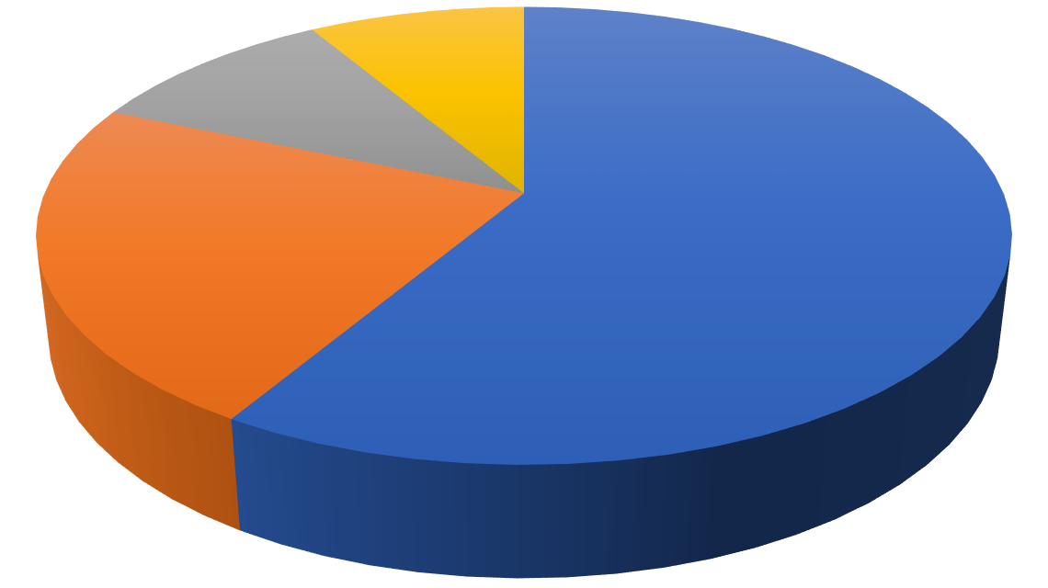

Preliminary Investigation  **20 Days**

System Analysis  **20 Days**

System Design  **15 Days**

Coding  **30 Days**

Testing  **5 Days**

Implementation  **5 Days**

Maintenance  **10 Days**

Project-Profile

* **Project Name : Employee Management System**
* **Developed by : Sarkhedi Mahek S.**
* **Developed by : Metaliya Unnat G.**
* **Frontend tool : PHP,HTML,CSS**
* **Backend tool : PHP MySQL**
* **Operating System : Microsoft Windows10 pro…**
* **Computer System : Pentium-IV or Higher, RAM:256MB**
* **Project Details : Provide best platform for**

**admin, Admin send a project for employer,**

**Employer send a leave request, admin manage a employee.**

* **Completion Time : 2.5 Months**
* **Guided by : Mr. S.M.Makwana**
* **Submitted by : Saurashtra University, Rajkot**

Hardware-Requirement

* + 512+MBOfRAM
  + Multimedia Keyboard And Mouse
  + GHz Processor
  + Monitor
  + Printer

Software-Requirement

* + Operating System: Microsoft windows10pro
  + Front End Tools: PHP,HTML,CSS,SublimeText3
  + Back End Tools : PHP MySQL
  + Documentation Tool: Microsoft word2007
  + Browser Specification: Google Chrome

,Mozilla Firefox

Requirement Specification

In this section provides requirements overview of the system.

* **Registration:**

**- Employee :**

If employer wants to post project then must be registered, unregistered employer can’t post project.

**- Admin:**

If employer want to get the project the must be registered, unregistered employer can’t get a project.

* **Login:**

Employee login to the system by enter in valid user id and password for the use important functionality of

system.

* **Add Employee:**

Admin add the employee.

* **Admin Send Project:**

Admin can easily send project using this system.

* **Send Project To Employer:**

After completed the project Employee send a project to admin and get a more mark.

* **Generation Report:**

After completing all activities employer get full report of project.

Project Problem Definition

* Maintain Employee Profile
* Maintain Project Filter
* Maintain Salary
* Maintain Mark Of Admin
* Maintain Allocated Work
* Maintain

Project Planning & Scheduling

Project planning is an aspect of Project Management, which comprises of various processes. The aim of these processes is to ensure that various Project tasks are well coordinated and they meet the various project objectives including timely completion of the project .Project Planning is an aspect of Project Management that focuses a lot on Project Integration. The project plan reflects the current status of all project activities and is used to monitor and control the project.

The Project Planning tasks ensure that various elements of the Project are coordinated and therefore guide the project execution. Project Scheduling is one of the most important task of Project Planning and also the most difficult tasks .In very large projects it is possible that several teams work on developing the project .They may work on it in parallel. However their work may be interdependent.

* **Project Planning & Scheduling a sender :-**

**System Analysis**

**Preliminary Investigation**

**System Design**

**Testing**

**Coding**

**Implementation**

**Maintenance**

System Analysis

System analysis is the process of identification of object island requirements, evaluation of alternative solution recommendation for a more feasible solution. In other words, system analysis is the step by step process of gathering, recording and interpreting facts. The main aim of analysis is to determine problem area sand total solutions limited them.

* System analysis itself breaks into two stages:
  1. Preliminary analysis :
  2. Detailed analysis :

During analysis, data are collected from the available files, decision points and transactions of the systems using various tools like Dataflow

Diagram (DFD).

Feasibility-Study

A purpose of feasibility study is to check out the possibility of a computerized solution to the

organization’s observed problem before very much money that has been.

A feasibility study is carried out to select the best system that meet s performance requirements .Only by spending the time to evaluate the feasibility reduce the chances for extreme embarrassment at later stage of the system project.

For the complete feasibility study Into concentrate on following Area:

* They are three type so feasibility Study:
  1. Technical
  2. Operational
  3. Economical

### Technical :

Technical feasibility considers whether the desired project can be completed within the

framework of available technology. As our project was website designing, this was not much of a problem, as many advanced web-editing tools area variable.

* **Operational :**

Operational feasibility was done to assure that the product that would be developed would be used. Since a cards and gifts have to have a website of its own sooner or later, that wasn’t much of problem.

* **Economical :**

Our Commercial Website is Economically Feasible Because. We have developed this website only coronet time. Only future enhancement is

required on the other hand every client can view our site any time or many time as per their

requirement. So the future economical expenses are null. So we can say that this website is totally economically feasible.

Project Page Structure

* **Employee-Side:-**

**My Project**

**Attendance**

**Logout**

**My Profile**

**Salary**

**Home**

**Leave**

**Employee**



* **Admin Side:-**

**Logout**

**Home**

**Update Password**

**Project Status**

**Assign Project**

**Add Employee**

**Employee**

**Leave**

**Salary**

**Attendance**

**Admin**

Data-Dictionary

The data Dictionary Is a set of table .My-SQL use sit to maintain information about this own database.

* **Data dictionary contains the following information:**
  + Name of the table of database.
  + User information such as privileges.
  + Name and data-type of all columns in data base table.
* **Database Name** : ems

1. **Users : Admin – Employee**

This Table Is used to store admin/employee information.

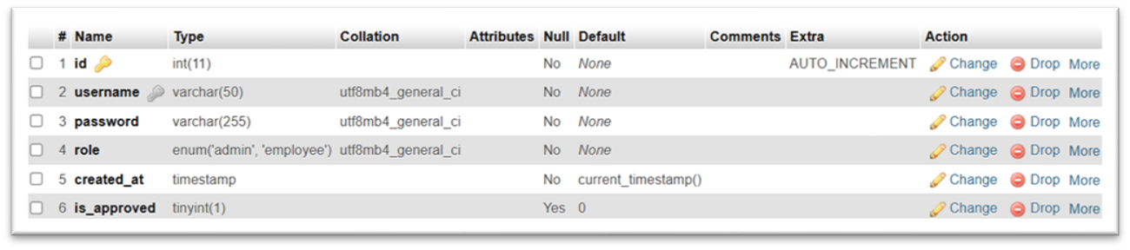

1. **Employee :**

This table is used to store add employee information.

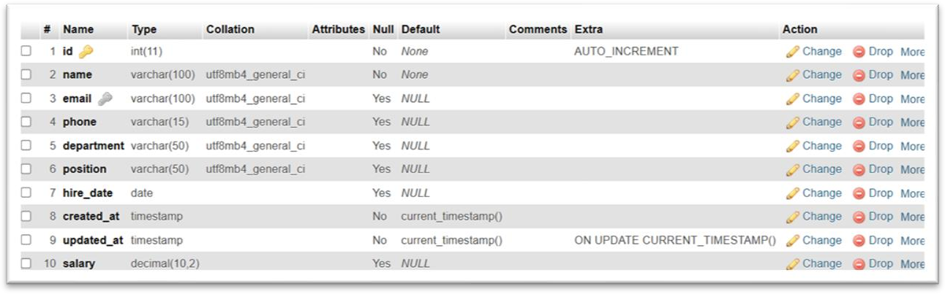

1. **Leave_requests:**

This table is used to employee leave all information.

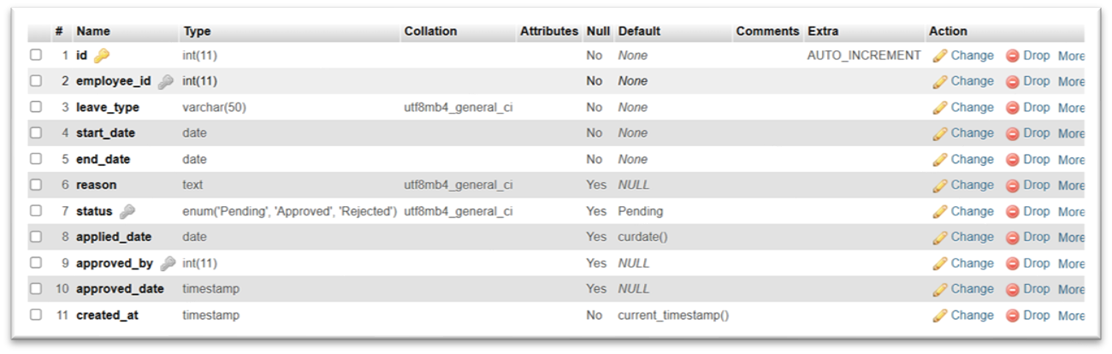

1. **Project:**

This table is used to store all Project Status information.

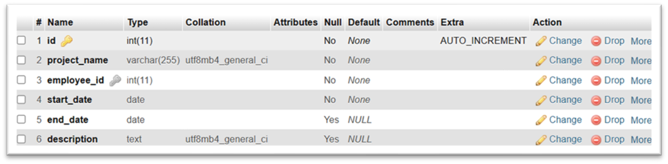

1. **Payroll /Salary** :

This table is used to store all information on salary.

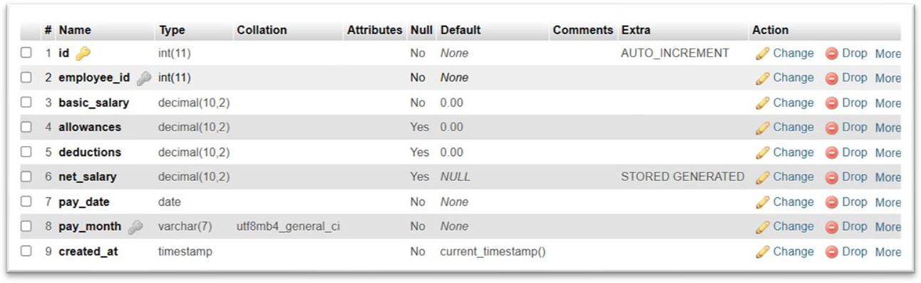

### Data-Flow Diagram

The DFD gives brief idea on how the designed system is working. It also suggests to us the type of users who using this system and the process involved in the system.

**Represent data-flow**

**Represent Entity**

**Represent a data table**

**Represent processing**



Context Level Diagram

Fill The Login Form

Check The Detail

Employee

0.0

Employee

Management System

Admin





Use Case Diagram Admin Side

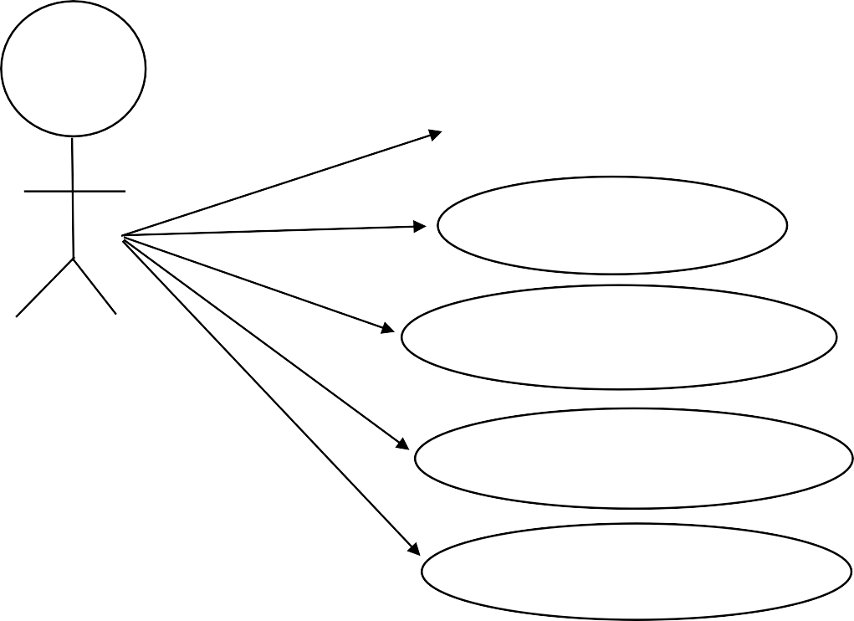

# Home

**Employee**

**Add Employee**

**Attendance**

**Leaves**

**Assign Project**

**Project Status**

**Update Password**

**Salary**

**Logout**

Employee Side

**Home**

**My Profile**

**Attendance**

**Leave**

**My Project**

**Salary**

**Logout**

## Activity Diagram



Login

Salary

Assign Project

Update Password

Leave

Add employee

Admin Side

**Login**

Ch–eck Username & Password

Employee

Attendance

Project Status

Logout





Login

Attendance

My Project

Logout

Home

My Profile

Leave

Salary

Employee Side

Check Username & Password

Screenshots

Front Side

* Home Page:-

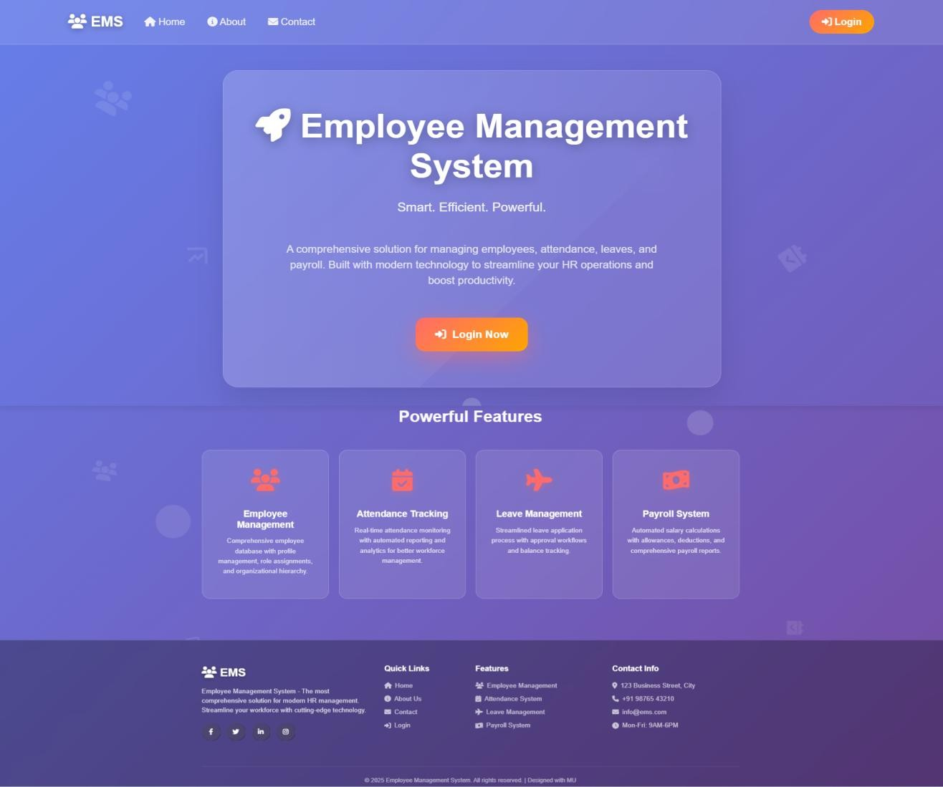

* About Us:-

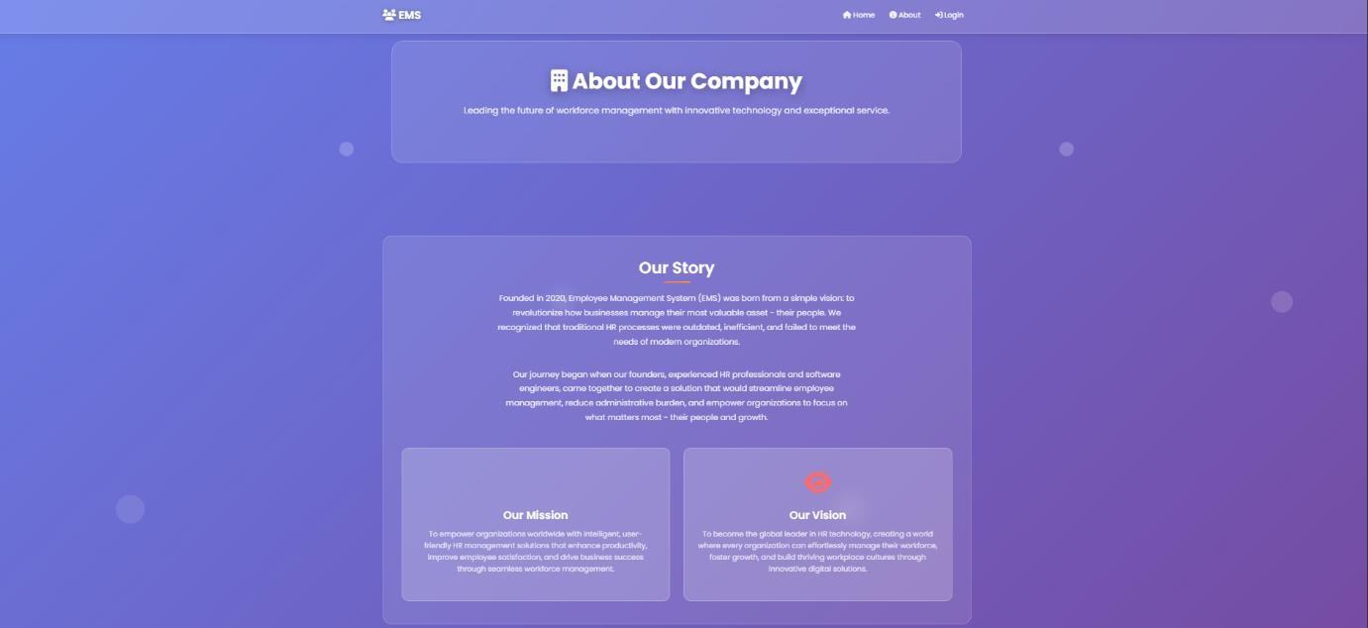

* Contact Us:-

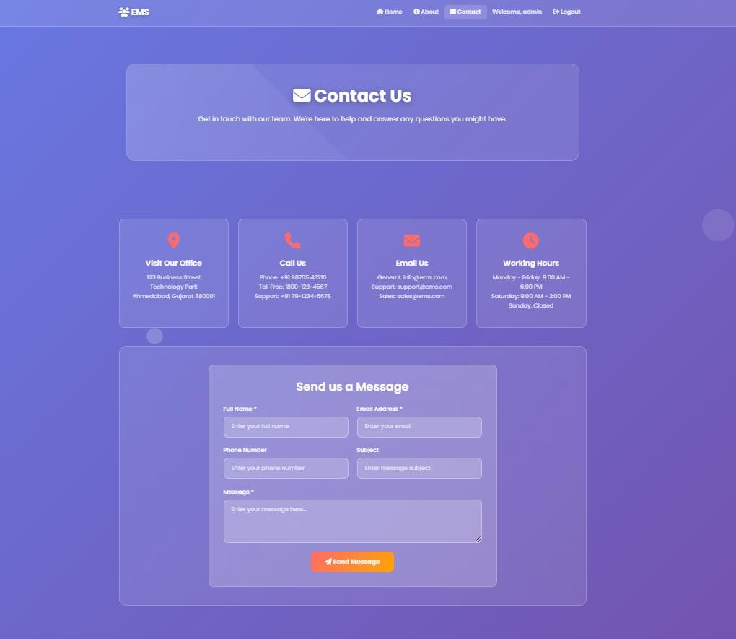

### Admin Side Screenshots

* Admin Login:-

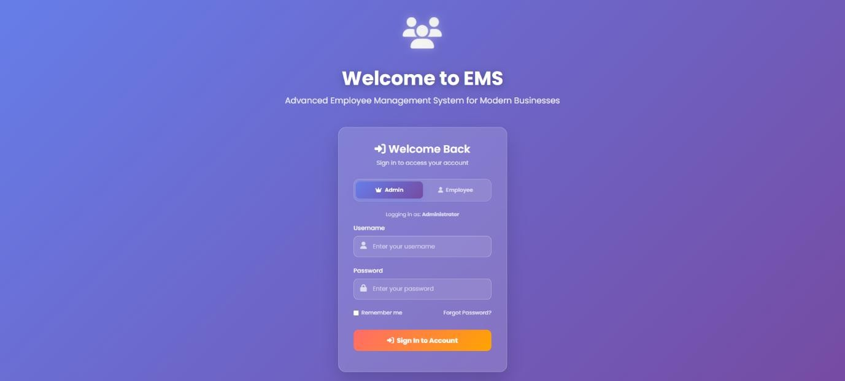

* Home Page:-

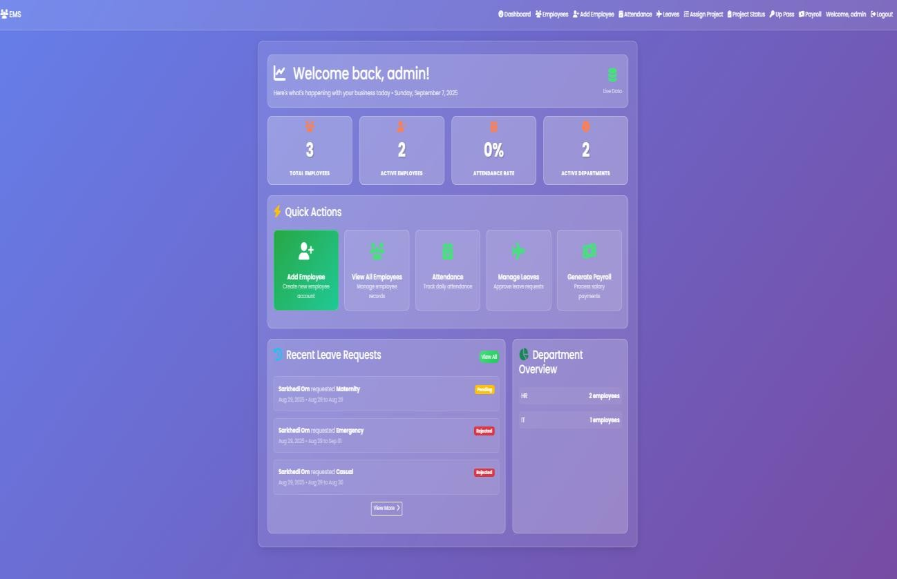

* Add Employee:-

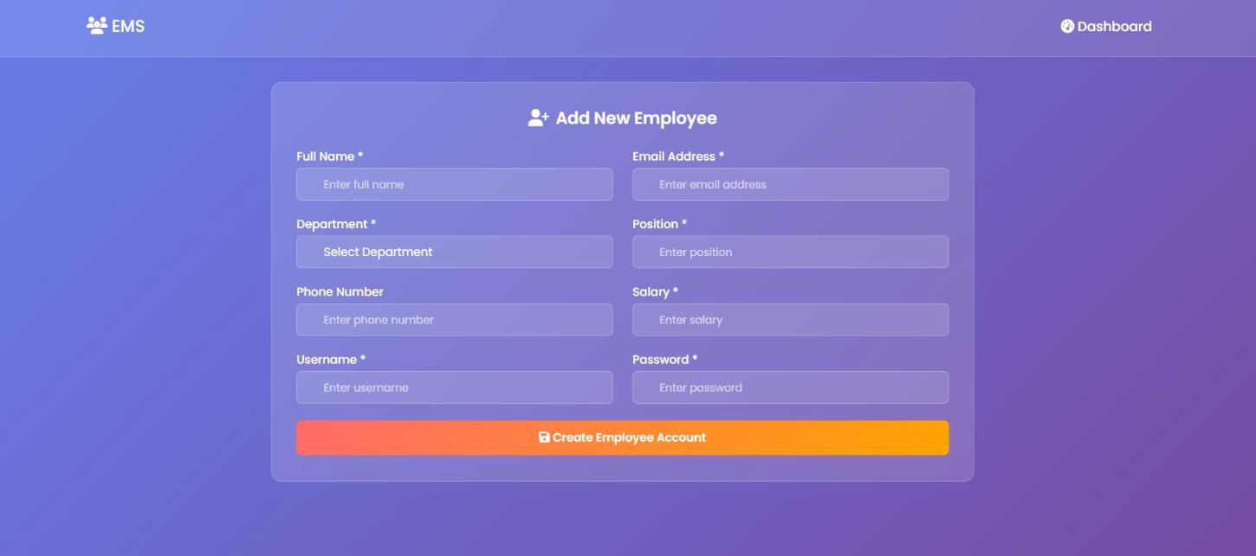

* View Employee:-

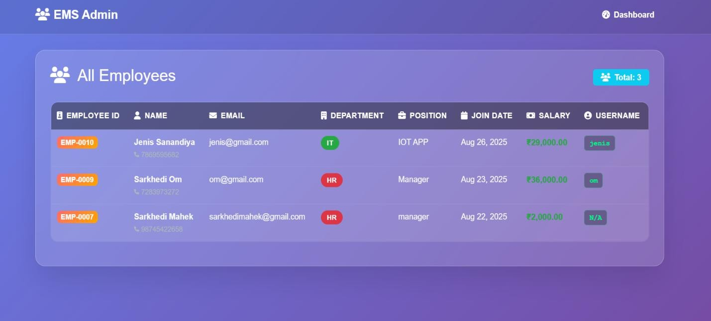

* Assign Project:-

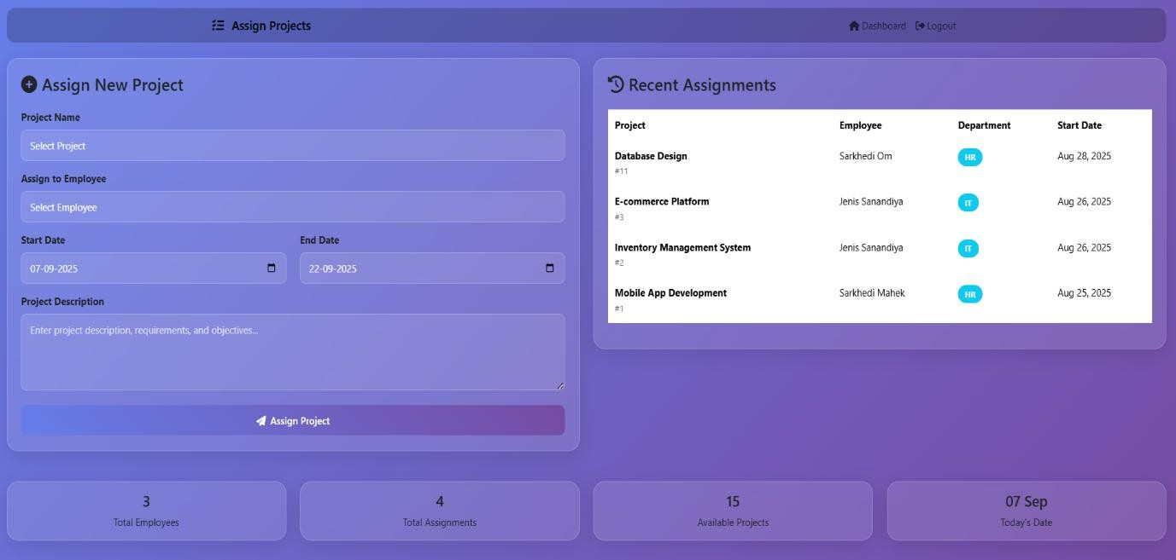

* Project Status:-

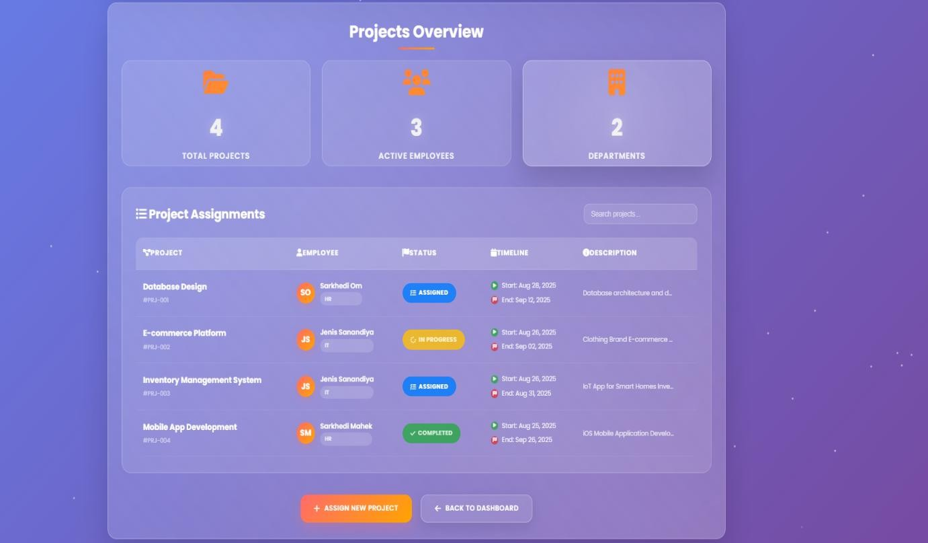

* Salary Table:-

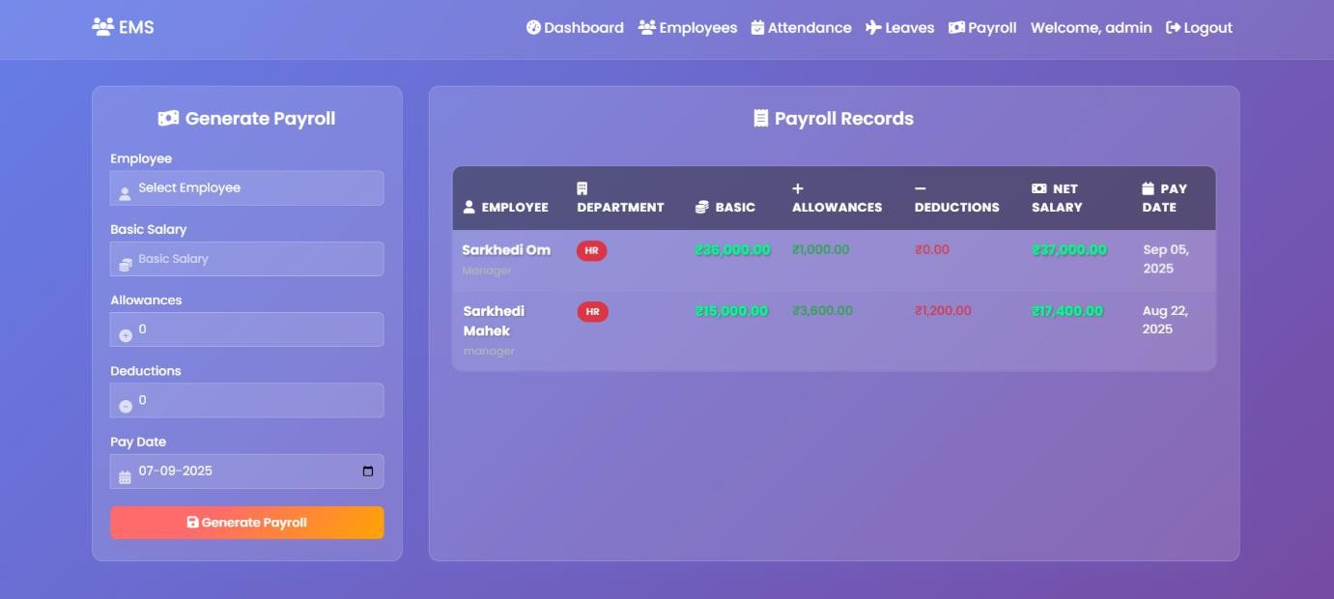

* Employee Leave:-

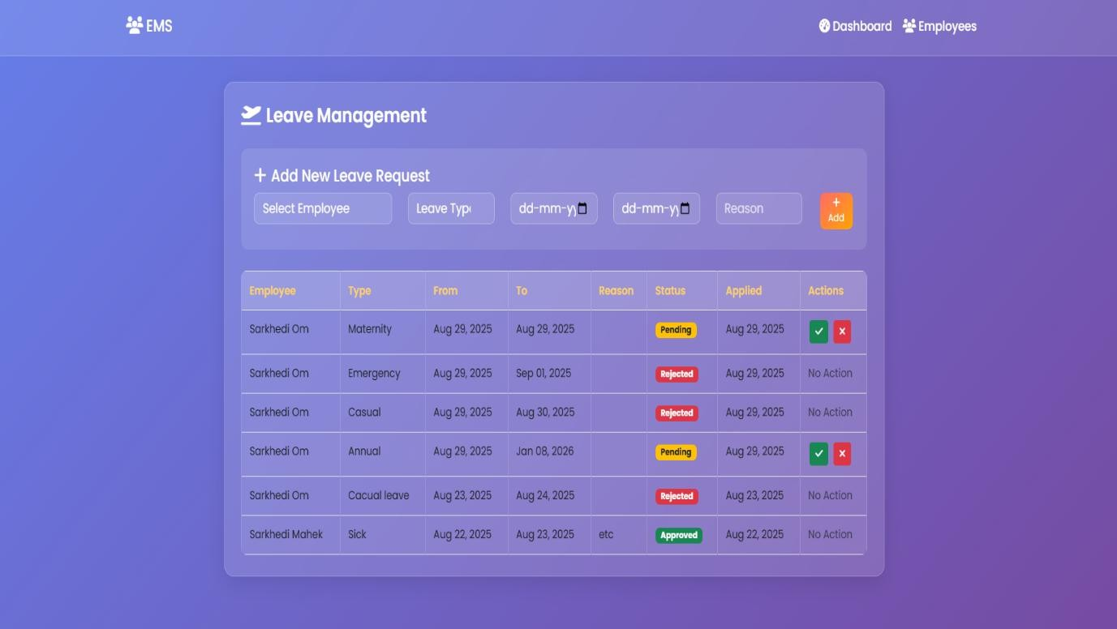

* Update Password:-

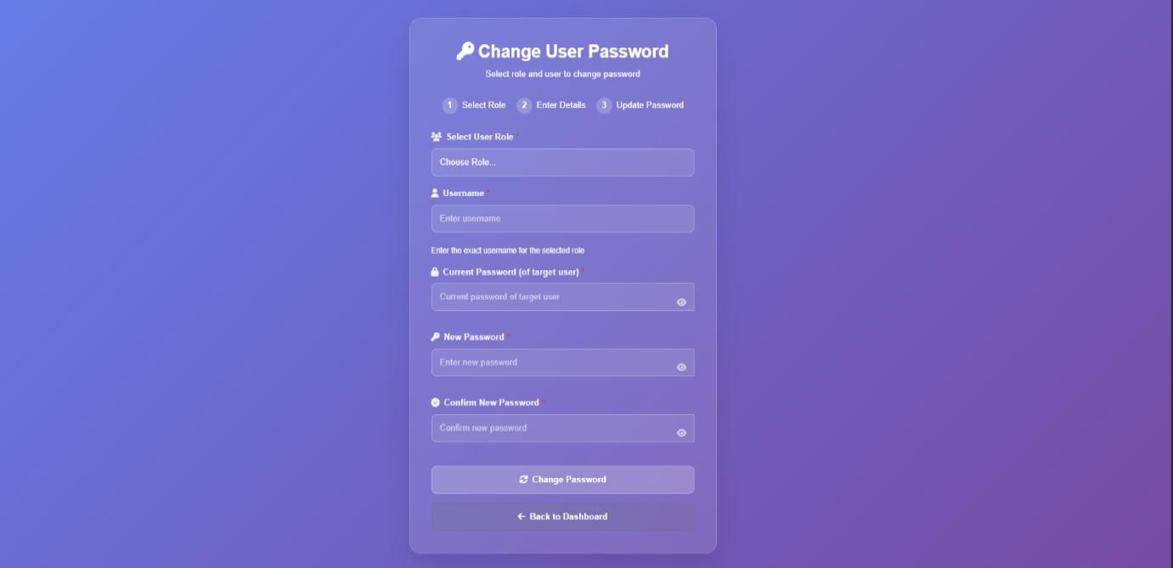

* Employees:-

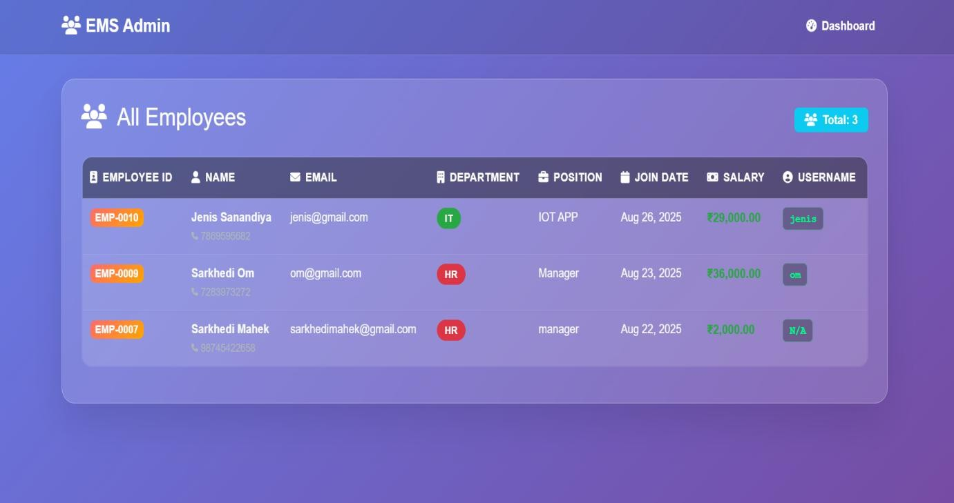

# Employee Side Screenshots

* Home Page:-

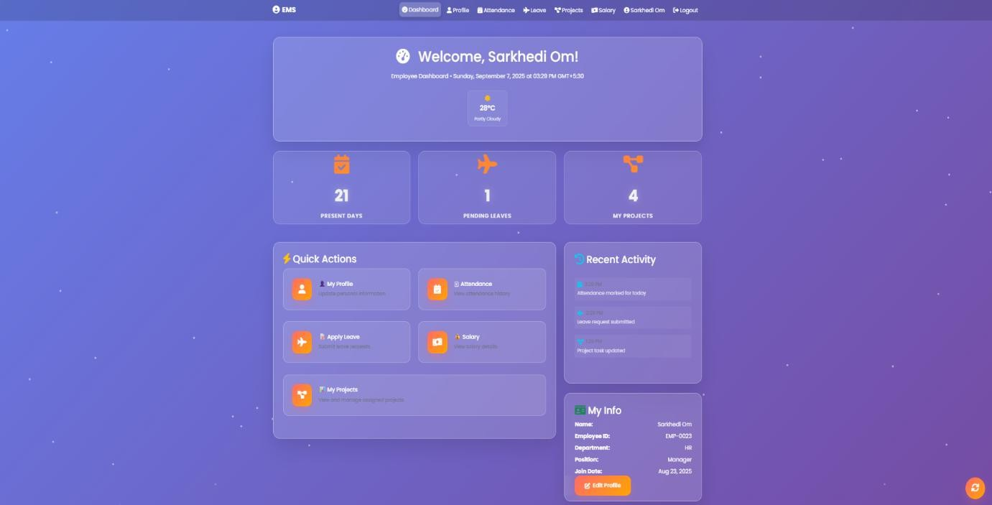

* My Profile :-

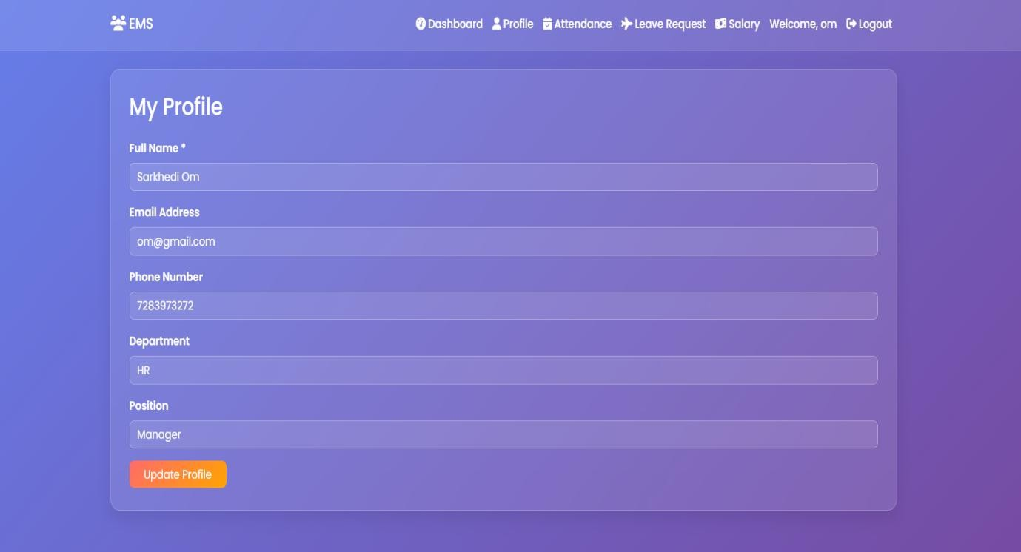

* My Project :-

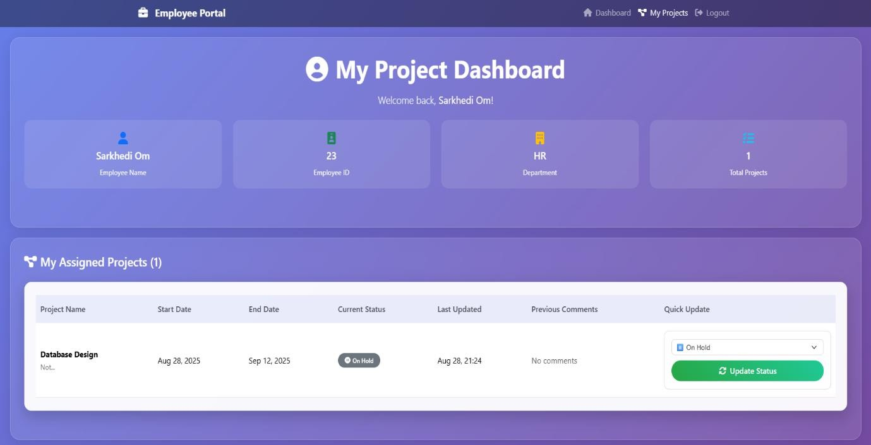

* Apply Leave:-

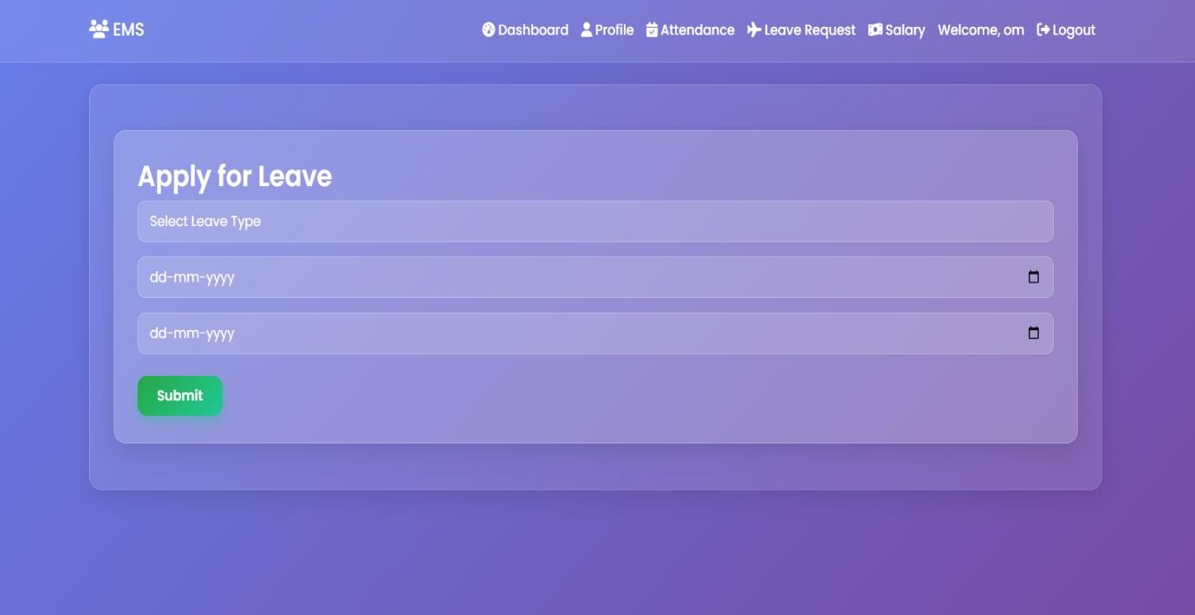

* Salary & Attendance :-

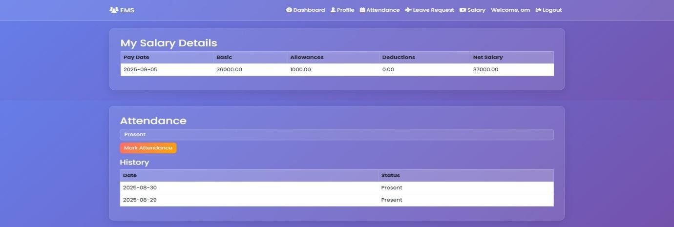

### Future-Scope

The **future scope** of this project to help most unemployed persons and help them to manage a employee.

The purpose of an employee management system is to help improve workforce productivity, identify ways to engage and retain talent, and alleviate administrative burdens for HR professionals.

Achieving greater efficiency through the use of technology can also help control costs and minimize compliance risks.

### Bibliography

1. Php Manual.
2. Professional PHP
3. [getbootstrap.com](https://getbootstrap.com/docs/5.0/getting-started/introduction/) 4. [](http://www.google.com/)

**This documentation is created by**

📝✨📁

**Sarkhedi Mahek S. & Metaliya Unnat G.**

# CD/DVD

Below items are included in CD/DVD.

* Project
* Database
* Documentation
* Screenshots